CHE517 ADVANCED PROCESS CONTROL
FINAL EXAM
Professor Shi-Shang Jang June 6, 2006

Problem #1 Interpretation: (20%)

(1) Multi-input/Multi-output (MIMO)
- Smith Predictor
- Feedforward Control
- Feedback Control
- First-Order Hold

Problem #2 (20%)

Consider the following process with three inputs and three outputs.
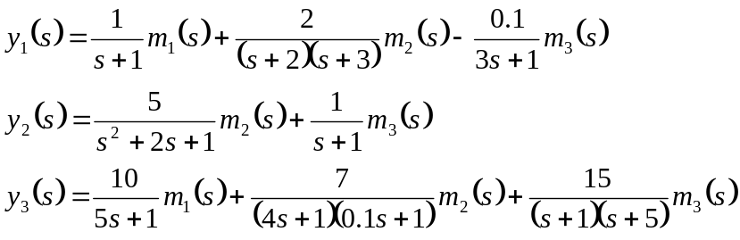
Using Bristol’s relative gain array, select the control loops with minimum steady state interaction.

Problem #3 (20%)

Derive a pulse transfer function (z-domain) for the following plants with a zero order hold and a sampling time of 1:
- 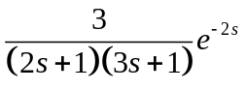 (7 points)
- 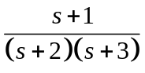 (7 points)
- 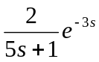 (6 points)
Problem #4 (20%)

A second order critically damped process has transfer function
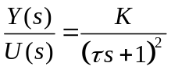
- For a step change in input of magnitude M, what is the time (ts) required for such a process to settle to within 5% of the total change in the output?
- For K=1 and a ramp change in input, u(t)=at, by what time period does y(t) lag behind u(t) once the output is changing linearly with time?

Problem #5 (20%)

LT
LC
From Process 1
h_{m}
h_{sp}
P_{v}
To Process 2
F₁
h
Design a feed-forward/cascade control strategy for the following level control problem. Draw the instrumentation directly on the figure. Draw a control block diagram, labeling all the signals on the diagram.

